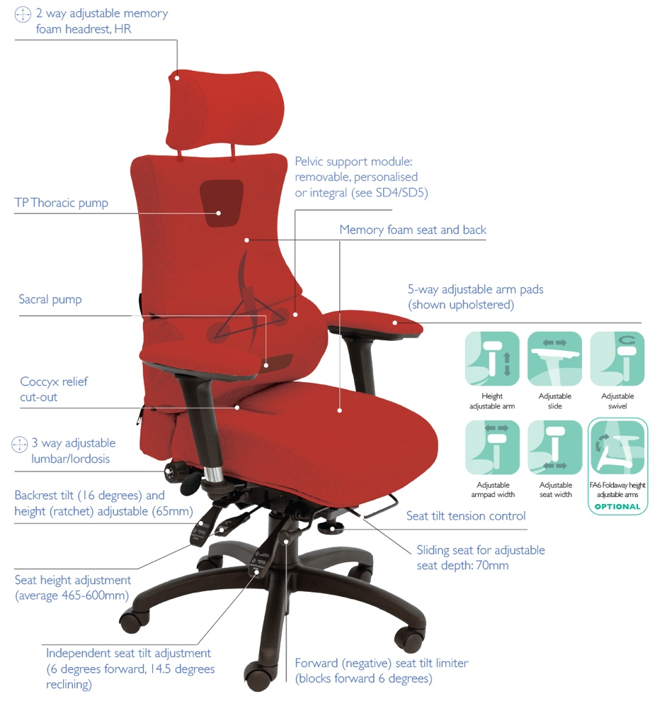
Each of the 3 chairs shown is designed in a modular fashion to ensure each part of the spine receives optimal support: pelvic (sacral) support through the pelvic module (cushion) and sacral pump, lumbar through the height and depth adjustable lumbar cradle and lumbar air bag (3-way) assembly and the shoulder height (thoracic) pump helps support the upper part of your back. The SD3 is the same as the SD2 with a neck/headrest – one can be fitted to the SD1 as well. The headrest is designed to fit at the top of the back if the cervical part of your spine needs extra support.
SD3 High Back with Headrest
SD1 Extra High Back
SD2 High Back
SD1 SD2 SD3
Chronic back pain seating
For more information and prices, please contact Phil Pask on 07803 120155
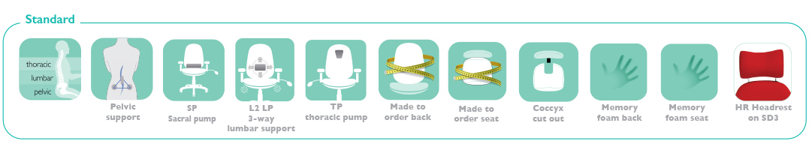

Ergonomic features include:

- The triangulation of support provided by the removable, personalisable pelvic cushion and the 3-way adjustable lumbar
- The sacral pump
- The Thoracic pump
- The coccyx relief cut out
- The use of memory foam in seat, back, headrest and arms
- 6-way adjustable forward tilting mechanism: adjustable for seat tilt, depth, height, tension (weight) control, backrest height (ratchet) and tilt
- 6 seats to complement 2 back configurations including 2 height and tilt adjustable headrests for custom built comfort
- 5-way adjustable memory foam-upholstered arms; adjustable for: height, depth (forward and back), width and (locking) swivel

